

**Absence Procedures**

If your child is going to be absent from school, you must ring and inform school before 9am on each day of absence by calling:

**0161 711 1023**

This is part of our safeguarding procedures to ensure we know where all our pupils are if they are not in school.

If contact is not received we will send *text messages and ring home, including emergency contacts.*

If no contact is made our school staff may visit you at home to ensure you and your children are well and to discuss reasons for absence.

If we have safeguarding concerns and we cannot locate/get into contact or obtain a valid reason for their absence, we may contact the Police requesting a ‘safe & well check’ – this is to ensure that you and your children are safe and will only be initiated when and where appropriate.

**It is your legal responsibility to ensure**

**that your child attends school.**

If your child has unauthorised absences from school, you may be at risk of a penalty notice fine or a referral being submitted to the Local Authority for prosecution.

Penalty notices incur a fine of **£160 per child**, **per parent**, which is reduced to £80 if paid within 21 days of the notice being served. Failure to pay this fine may result in being summoned to appear in the Magistrates Court.

**Remember**: **EVERY** Child has the **right** to an education!

* **School starts at 8:50am prompt, gates will open at 8:40am**
* **School closes at 3:20pm prompt, gates will open at 3:10pm**
* **Breakfast club is available from 8:00am, children must be there before 8:30am**

**Varna Community**

**Primary School**

**Attendance & Punctuality Information Parents**

**Attendance Matters!**

Here at Varna Community Primary School, we believe that pupils need to attend school regularly and consistently in order to excel in school.

We as a school want to work together to ensure that your children are happy and enjoy coming to school to learn, develop and socialise with their peers.

Our full attendance policy is available on school’s website:

https://www.varna.manchester.sch.uk/

**Leave of absence in term-time will not be authorised** and you will receive a penalty notice.

Any pupils whose attendance is 90% or below is classed by the DFE as a **“persistent absentee”**

We will request **medical evidence** if your child is off poorly and their attendance is concerning us. Absences will be **unauthorised** where we do not receive this.

**Percentages Matter!**

If your child’s attendance is 90% at the end of the school year, **they have missed a total of 19 days of learning!** 90% attendance over the 11 years your child attends school will equal **one whole year missed!**

**Punctuality Matters!**

If your child is late by 10 minutes every day, by the end of the week they have missed nearly an hour of learning – ***that could be a whole Maths or English lesson!***

**What school will do to support your child’s attendance:**

* We will **celebrate** and praise good and/or improved attendance.
* We will **work together** with parents and families.
* We will **keep you informed** about your child’s attendance and punctuality regularly.
* We will **make referrals** to other agencies for support where necessary.
* We will make **home visits** where necessary to discuss your children’s attendance.
* We will make phone calls and invite you in to meetings to discuss attendance concerns and work together to **put plans in place**.

**How can parents support their children’s attendance?**

* **Talk to your children** about their day at school and celebrate their achievements.
* Remind your child that **attendance is important** and it is **not OK** to miss school. NHS guidance states that children are fine to attend school with minor coughs and cold symptoms.
* **Avoid unnecessary absence** - Make medical appointments outside school hours and do not go on holiday in term-time.

If your child is regularly late for school after the register closes, you may receive a penalty notice

If your child has regular unauthorised absences you will receive a penalty notice.

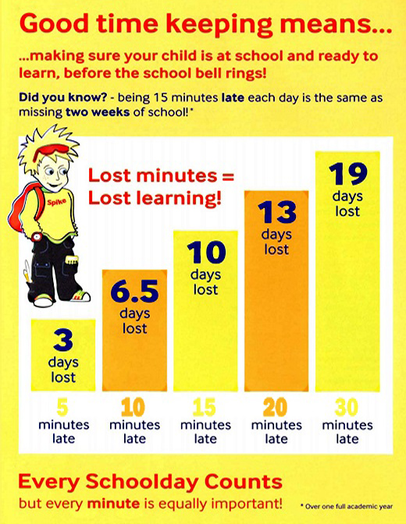

Good morning routines are essential to get your child into school on time.

Varna wants to work with you and support you to achieve 100% where possible.

Communication is vital to enable this to happen. **If you have any questions or concerns relating to attendance, please make an appointment with one of the team.**