Year 1 Long Term Plan
Year 1 LONG TERM PLANNING 2024 -2025

 | AUTUMN 1 | AUTUMN 2 | SPRING 1 | SPRING 2 | SUMMER 1 | SUMMER 2
Themes linked to (Science / Geography / History)  Key Text: | Animals and Living Things | Where Do I Live?  Autumn / Winter  Flying Kites | Famous Queens  Moving Pictures | Around the World  African Art | Castles  Andy Goldsworthy | The Four Seasons  Eat Fruit and Veg
 | Pumpkin Soup  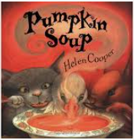 | The Jolly Postman  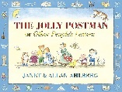 | Where the Wild Things Are  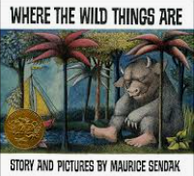 | Meerkat Mail  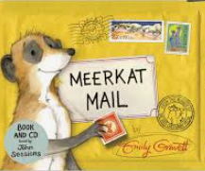 | Jack and the Beanstalk  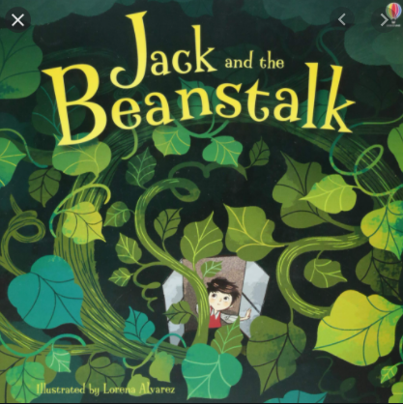 | 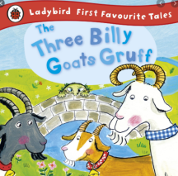  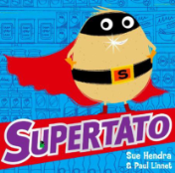  Billy’s Bucket  
Fiction
Linked Texts & Favourite 5
 | Knuffle Bunny  Dogger  The Enormous Turnip  Ruby’s Worry  That is Not my Hat. | Beegu  Amazing Grace  Room on the Broom  The Elves and the Shoemaker  Good Little Wolf | Traction Man is Here  The Proudest Blue  Monster Zoo  The Bear and the Piano  The Troll | The Elephant and the Bad Baby  Chapati Moon  The Name Jar  The Enormous Crocodile/The Selfish Crocodile  The Dinosaur who pooped … | Dr Xargle’s Book of Earthlets  On Sudden Hill  Cops and Robbers  Supertato  Jabari Jumps | Avocado Baby  The Night Pirates  The Giant Jam Sandwich  I am Enough!  The Owl and the Pussycat
Non-Fiction Linked Texts | How many Seeds in a pumpkin?  From a seed to a plant  How plants grow. | National Geographic kids – Wolves  Mission Wolf | World Atlas  Top 10 facts about wild beasts | Meet the Meerkat. Want to know more?  The big book about Meerkats.  African animals – the little explorer | From Seed to Plant  Plant life cycles  Food we eat | Sea Life  Under the Sea  Animalalium
Topic  (Hist, Geog, Art, DT, RE)  Please note – Science; Plant Detectives comes before Plants and Animal Antics comes before Looking at Animals. Sensing Seasons needs to be touched up in all four seasons so children can analyse change. Our Changing World Units need to be repeated every seasons over the year; these are Plants, Sensing Seasons and Animal Antics | H-Guy Fawkes  This happened in September  R – Judaism  Are Rosh Hashanah and Yom Kippur important to Jewish children?  A-PAINTING – Seasons: Artist: David Hockney/Damien Hirst  Links to PHSE and also science – they could draw themselves in their Autumn clothes and then compare to other seasons to create a piece of art word over the year  S –Seasons Autumn – 5 lessons (Our Changing World Diary) Then can begin Everyday Materials, as it is a longer unit.  PSHE - Mental and Emotional Help | G- Where do I live?  R- Christianity  Christmas Story  What gift would I have given to Jesus if he had been born in my town, not Bethlehem?  DT- Flying Kites  S – Naming and describing materials - 10 core, 3 enrichment/introduction  Links to DT e.g. what materials should they use? Favourite 5 – links to what materials should the Elves use to make their gifts etc  PSHE - Living in the wider world | H-Famous Queens  African Queens and compare to ours? Look at Amina Mohamud, Kandake, Makeda, Nefertiti, Yaa Asantewa, Queen Nandi, Queen Moremi. Find where they live on the map (Reinforcing Around the World skills)  R- Christianity  Jesus as a Friend  Was it always easy for Jesus to show friendship?  DT- Moving Pictures  S – Using our senses Spring – 5 lessons (Our Changing World Diary)  PSHE – Keeping safe | G-Around the World  A - COLLAGE Artist: Hundertwasser  R- Christianity  Easter – Palm Sunday  Why was Jesus welcomed like a king by the crowds on Palm Sunday?  S – Animals– 3 core, 2 enrichment/introduction and Looking at Animals – 7 core, 5 enrichment/introduction  PSHE - Healthy Lifestyles | H- Childhood now and then  R- Judaism  Stories  Is Shabbat important to Jewish children?DT- Eat fruit and Veg  S – Identifying Plants and their parts – 5 core, 2 enrichment/introduction and Plants – 5 lessons (The start of this module looks at changes over the year but lesson 4 and 5 are planting and then eating what we have produced. Focus on these)  Will need to start thinking about planting in Spring 1 and over Easter  PSHE - SRE | G-The Four Seasons  A-DRAWING– Where The Wild Things Are  R- Judaism  Rosh Hashanah and Yom Kippur  Are Rosh Hashanah and Yom Kippur important to Jewish Children?  S – Properties and uses of materials Summer - 5 lessons (Our Changing World Diary)  PSHE - Transition
Maths | Numbers to 10.  Part-whole within 10.  Addition and subtraction within 10.  2D and 3D shapes.  Numbers to 20. |  | Addition within 20.  Subtraction within 20.  Numbers to 50.  Introducing length and height.  Introducing weight and volume. |  | Multiplication  Division  Halves and Quarters  Position and Direction  Numbers to 100.  Time Money.
Enrichment | Pick Pumpkins at Farm and make Pumpkin Soup | Visit local Woods | Hold A Wild Rumpus | Visit from Meerkats | Grow our own Beans and Vegetables | Visit the Seaside
 | 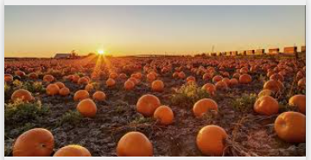 | 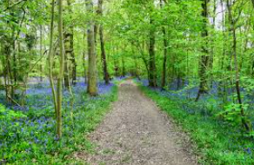 | 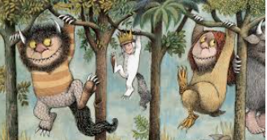 | 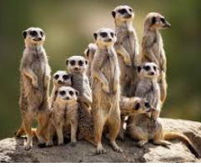 | 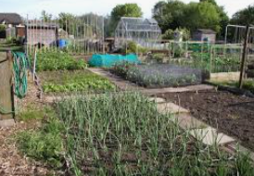 | 